Functions
Prepared: TrangNTT
Lab 3-2. Functions 1
2.1. Create a PHP project 2
2.2. Guess Heads Or Tails 3
2.3. Guess a number 4
2.4. Using printf function 4
2.5. Sale 4
2.6. CarpetEstimate 5
2.7. Exercise 6

Create a PHP project

Open Zend Studio 7.0
- Select Start → All Programs → Zend Studio – 7.0.0 → Zend Studio – 7.0.0
- Choose OK to confirm the workspace.
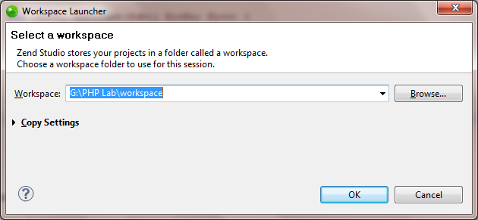
- There should be a project named Lab3 as the result of the previous lab.
- Close all the opening file in the PHP Editor view by right click to a file and choose Close All.
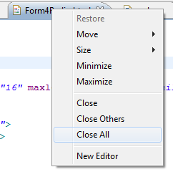

Guess Heads Or Tails

Create HeadsOrTails.php
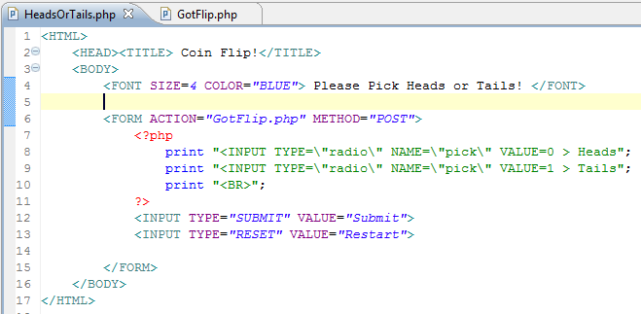

Create GotFlip.php
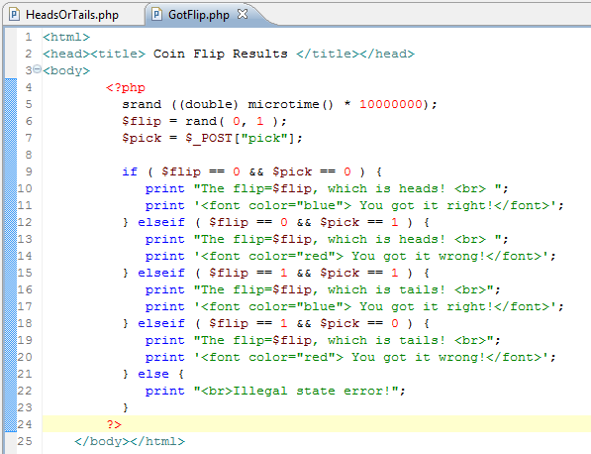

Run the ConditionalTest.html
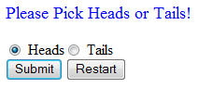

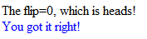

Guess a number
Create a GuessANumber.php file to process a game which allows users to guess a number from 0 to 100.
The system first get a random number from 0 to 100. Then the system ask the user to enter a number, if the number the user guesses is less than the random number, notify “Wrong. Please try a higher number. You have guessed 1 time!”. Otherwise, notify “Wrong. Please try a lower number. You have guessed 1 time!”. Then the user enter another number, so on…
Note to vaidate the number the user entered (text box). If it is not a number, please notify “You must enter a number!”.

Using printf function
Change the following part to ConditionalTest.php in Lab4. Run and observe the result.
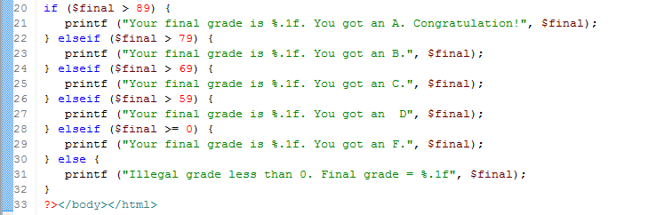

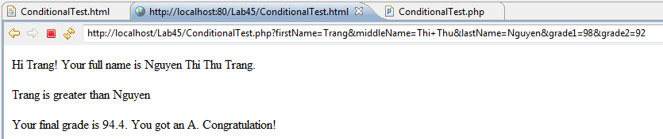

Sale
Create Sale.php to give date information for sale.
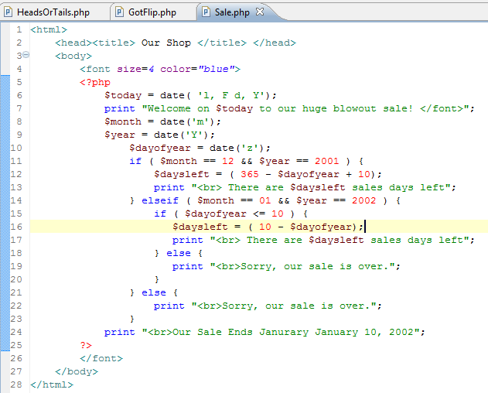

CarpetEstimate

Create Carpet Estimate.html
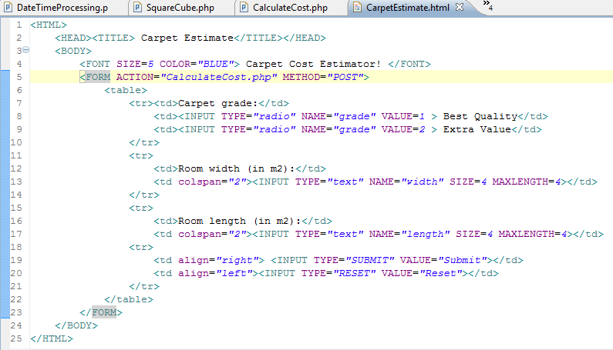

Create CalculateCost.php
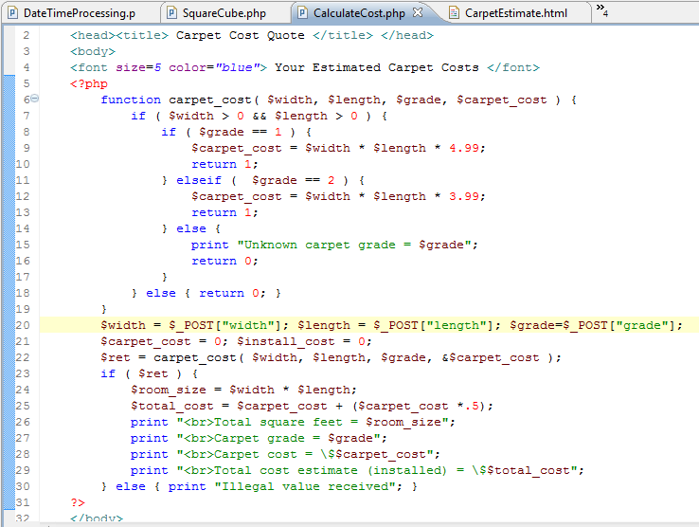

Run and observe the result
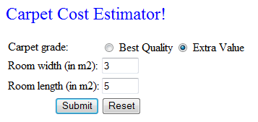

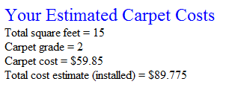

Exercise
            - Write a function to convert radians to degrees and vice versa. Write .php file allowing users to enter 1 factor, and print the other factor.
            - Create a DateTimeFunction.php to do the following jobs:
  - Allows users enter two names and their birthdays in number (E.g. 12/12/2008)
  - Validate them if two birthdays
  - If OK, give the following information by write your own functions and call them
    - Display in two dates in letter (E.g. Friday, December 12, 2008) for each person
    - Calculate the difference in days between two dates.
    - Calculate how old are they, the difference years between two persons.

